INSIDE

OBJECTIVE

ACADEMIC
QUALIFICATIONS

LANGUAGE

COMPUTER
LITERACY

HOBBIES
& INTEREST

PERSONAL INFORMATION

SERVICE EXPERIENCES

SUPPORTIVE INFORMATION

DECLARATION

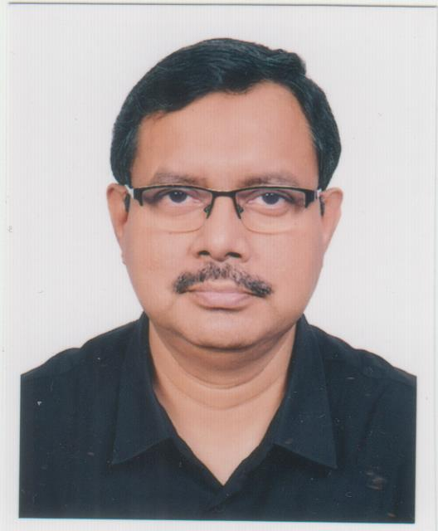

RESUME
OF
MD. SALAHUDDIN
Cell: 01325697407

House No-518/E, Road-12,
Baitul Aman Housing Society, Adabor, Shyamoli, Dhaka-1207
E-mail:mdsalahuddin331968@gmail.com

Md. Salahuddin

To work in a dynamic position, which will provide me with an opportunity to utilize and develop ability, skill and qualification as to take the challenge of the day.

I.C.M.A.B.
Corse completed and out of 20 subject 15 subject passed.
I.C.M.A. intermediate (12 papers) qualified successfully in January 1992 and also passed 2 papers for Final Group-I and 1 paper for Final Group-II

Bachelor of Science (B.Sc.)
Subject : Physics, Chemistry and Mathematics
Institute : Dhaka Collage
Board : Dhaka
Passing Year : 1988
Result : 2nd Division

Higher Secondary Certificate (H.S.C)
Institute : Notordame College
Group : Science
Board : Dhaka
Passing Year : 1985
Result : 2nd Division

Secondary School Certificate (S.S.C)
Institute : Ideal High School
Group : Science
Board : Dhaka
Passing Year : 1983
Result : 1st Division

English & Bengali: Good Reading, Speaking and Writing.

Application Course: MS Word, MS Excel, Accounting Based Software, Internet & Other’s.

Gardening

Name : Md. Salahuddin
Father’s Name : Md. Khabiruddin
Mother’s Name : Mrs. Hasna Hena
Date of Birth : 3rd March 1968
Height : 5’10”
Weight : 85kgs
Permanent Address : House-518/E, Road-12, B.A.H.S.
Post: Mohammodpur
Thana: Adabor, Dist: Dhaka.
Nationality : Bangladeshi (By Birth)
Religion : Muslim
Sex : Male
Marital Status : Married

OBJECTIVE
RESUME OF
ACADEMIC QUALIFICATION

LANGUAGE
PROFICIENCY

COMPUTER
LITERACY
HOBBIES & INTEREST

PERSONAL INFORMATION

- SHADE GROUP.
A. Shade Business Line Ltd. (Buying House)
B. Shade Fashions Ltd. (Garments)
C. Shade Fashions International Ltd. (Garments)
D. P & O Attires Ltd. (Garments)

Since February 2002 to February 2019

Designation: Accounts Manager

Job Description:
- Reporting to Managing Director and provide necessary information regarding Fund Management as an Accounts Manager.
- Preparing all kinds of cheque and maintain Bank book.
- Control Ledger posting.
- Preparation of Trial Balance, Income Statement and Balance Sheet.
- Preparation of Salary sheet.
Also take care of 3 Garments Factory
- Preparing all kinds of cheque and maintain Bank book.
- Control Ledger posting.
- Preparation of Trial Balance, Income Statement and Balance Sheet.
- Look after purchase for all 3 Factories maintenance work.
- Maintenance of all vehicles and recruit driver.
- Look after Security department and recruit Security staff.

- GEC GROUP COMPANIES BANGLADESH

Since April, 1993 to September, 2000.

Designation: Accounts Executive

Job Description:
- Reporting to Finance Director and provide necessary information as an Accounts Executive.
- Control Ledger Posting.
- Preparation of Trial Balance, Income Statement and Balance Sheet.
- Preparation of monthly Group Management Accounts and returns to the UK Head Office.
- Preparation of working papers and finalization of the Annual Budget.
- Preparation of the Year-end working papers and final year-end report forms for the Company in conjunction with the Auditors.

Signature

RinaAkther

Date:…………………………
SERVICE EXPERIENCES

DECLARATION
INFORMATION IN SUPPORT OF MY APPLICATION

In the space below a statement in support of my application indicating what skill I have gained by now that I am able to contribute for the post.
For your kind information I am giving some of my slight experiences in support of my application:-
- I have maintain oversee entire administrative functions such as office administration, utility, Logistic support, cleanliness, security, compliance issues at corporate office and unit offices,
- I have 26 years’ experience of handling accounts department as well as administrative department.
- Good communication and negotiation skills (Both English and Bangla).
- I have maintain communication with our factory office and supply all kinds of machinery parts, electrical items and stationery items.

I certify that all particulars given are correct & true

Md. Salahuddin

Date : 19.05.2026

DECLARATION

